LAB 8

**PART 1**

**CODE**

<!DOCTYPE html>

<html lang="en">

<head>

<meta charset="UTF-8">

<meta http-equiv="X-UA-Compatible" content="IE=edge">

<meta name="viewport" content="width=device-width, initial-scale=1.0">

<title>LAB 14 A</title>

<link rel="stylesheet" href="https://cdn.jsdelivr.net/npm/bootstrap@4.0.0/dist/css/bootstrap.min.css" integrity="sha384-Gn5384xqQ1aoWXA+058RXPxPg6fy4IWvTNh0E263XmFcJlSAwiGgFAW/dAiS6JXm" crossorigin="anonymous">

<script src="https://cdn.jsdelivr.net/npm/bootstrap@4.0.0/dist/js/bootstrap.min.js" integrity="sha384-JZR6Spejh4U02d8jOt6vLEHfe/JQGiRRSQQxSfFWpi1MquVdAyjUar5+76PVCmYl" crossorigin="anonymous"></script>

<script src="https://code.jquery.com/jquery-3.2.1.slim.min.js" integrity="sha384-KJ3o2DKtIkvYIK3UENzmM7KCkRr/rE9/Qpg6aAZGJwFDMVNA/GpGFF93hXpG5KkN" crossorigin="anonymous"></script>

<script src="https://cdn.jsdelivr.net/npm/popper.js@1.12.9/dist/umd/popper.min.js" integrity="sha384-ApNbgh9B+Y1QKtv3Rn7W3mgPxhU9K/ScQsAP7hUibX39j7fakFPskvXusvfa0b4Q" crossorigin="anonymous"></script>

<style>

h5{

color: white;

}

.card-deck{

padding: 20px;

}

body{

background-color: beige;

}

.card{

border-radius: 5px;

}

</style>

</head>

<body>

<div class="card-deck">

<div class="card">

<img src="paper clip.jpg" style="height: 150px; width: 150px;">

<div class="card-body">

<h5 class="card-title" style="color:dodgerblue;">PAPER CLIP</h5>

<small class="card-text">Model: SS-111 <br>Pieces in a box:12<br><a href="#">Read more</a></small>

<div class="card" style="width: 80px; margin-left:200px ; margin-top: -60px; background-color: rgb(12, 115, 233);">

<h5>Rs.65</h5>

<small style="color: white; background-color: blue;">Per Piece</small>

</div>

</div>

</div>

<div class="card">

<img src="ball pen.jpg" style="height: 150px; width: 150px;">

<div class="card-body">

<h5 class="card-title" style="color:dodgerblue;">BALL PEN</h5>

<small class="card-text">Model: BP-222 <br>Pieces in a box:100<br><a href="#">Read more</a></small>

<div class="card" style="width: 80px; margin-left:200px ; margin-top: -60px; background-color: rgb(12, 115, 233);">

<h5>Rs.12</h5>

<small style="color: white; background-color: blue;">Per Piece</small>

</div>

</div>

</div>

<div class="card">

<img src="marker.jpg" style="height: 150px; width: 200px;">

<div class="card-body">

<h5 class="card-title" style="color:dodgerblue;">MARKER</h5>

<small class="card-text">Model: MKR-04<br> Pieces in a box:12<br><a href="#">Read more</a></small>

<div class="card" style="width: 80px; margin-left:200px ; margin-top: -60px; background-color: rgb(12, 115, 233);">

<h5>Rs.45</h5>

<small style="color: white; background-color: blue;">Per Piece</small>

</div>

</div>

</div>

<div class="card">

<img src="stapler.jpg" style="height: 150px; width: 200px;">

<div class="card-body">

<h5 class="card-title" style="color:dodgerblue;">STAPLER</h5>

<small class="card-text">Model: STP-1160<br> Pieces in a box:20<br><a href="#">Read more</a></small>

<div class="card" style="width: 80px; margin-left:200px ; margin-top: -60px; background-color: rgb(12, 115, 233);">

<h5>Rs.750</h5>

<small style="color: white; background-color: blue;">Per Piece</small>

</div>

</div>

</div>

</div>

<div class="card-deck">

<div class="card">

<img src="paper punch.jpg" style="height: 150px; width: 200px;">

<div class="card-body">

<h5 class="card-title" style="color:dodgerblue;">PAPER PUNCH</h5>

<small class="card-text">Model: PPM-200<br> Pieces in a box:8<br><a href="#">Read more</a></small>

<div class="card" style="width: 80px; margin-left:200px ; margin-top: -60px; background-color: rgb(12, 115, 233);">

<h5>Rs.300</h5>

<small style="color: white; background-color: blue;">Per Piece</small>

</div>

</div>

</div>

<div class="card">

<img src="printing.jpg" style="height: 150px; width: 200px;">

<div class="card-body">

<h5 class="card-title" style="color:dodgerblue;">PRINTING</h5>

<small class="card-text">Model: Dr-210 <br>Pieces in a Carton:6<br><a href="#">Read more</a></small>

<div class="card" style="width: 80px; margin-left:200px ; margin-top: -60px; background-color: rgb(12, 115, 233);">

<h5>Rs.2500</h5>

<small style="color: white; background-color: blue;">Per Piece</small>

</div>

</div>

</div>

<div class="card">

<img src="pencil.jpg" style="height: 150px; width: 200px;">

<div class="card-body">

<h5 class="card-title" style="color:dodgerblue;">PENCIL</h5>

<small class="card-text">Model: P-01 Pieces <br>in a box:12<br><a href="#">Read more</a></small>

<div class="card" style="width: 80px; margin-left:200px ; margin-top: -60px; background-color: rgb(12, 115, 233);">

<h5>Rs.08</h5>

<small style="color: white; background-color: blue;">Per Piece</small>

</div>

</div>

</div>

<div class="card">

<img src="file folder.jpg" style="height: 150px; width: 200px;">

<div class="card-body">

<h5 class="card-title" style="color:dodgerblue;">FILE FOLDER</h5>

<small class="card-text">Model: FF-020 Pieces<br> in a box:15<br><a href="#">Read more</a></small>

<div class="card" style="width: 80px; margin-left:200px ; margin-top: -60px; background-color: rgb(12, 115, 233);">

<h5>Rs.90</h5>

<small style="color: white; background-color: blue;">Per Piece</small>

</div>

</div>

</div>

</div>

</body>

</html>

RESULT:

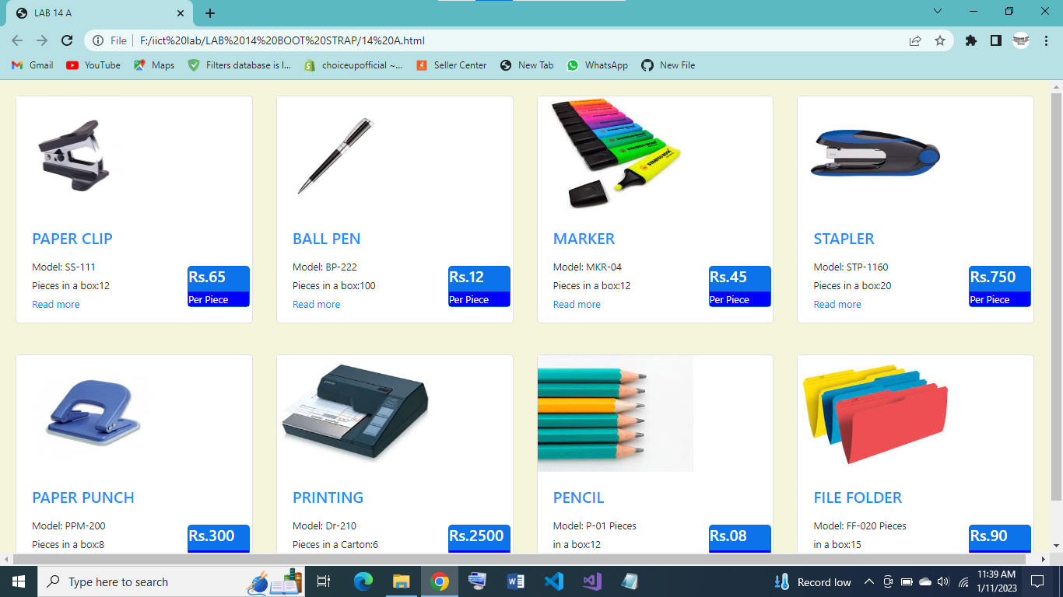

**PART 2**

**CODE:**

<!DOCTYPE html>

<html lang="en">

<head>

<meta charset="UTF-8">

<meta http-equiv="X-UA-Compatible" content="IE=edge">

<meta name="viewport" content="width=device-width, initial-scale=1.0">

<title>BOOTSTRAP</title>

<link rel="stylesheet" href="https://cdn.jsdelivr.net/npm/bootstrap@4.0.0/dist/css/bootstrap.min.css" integrity="sha384-Gn5384xqQ1aoWXA+058RXPxPg6fy4IWvTNh0E263XmFcJlSAwiGgFAW/dAiS6JXm" crossorigin="anonymous">

<script src="https://cdn.jsdelivr.net/npm/bootstrap@4.0.0/dist/js/bootstrap.min.js" integrity="sha384-JZR6Spejh4U02d8jOt6vLEHfe/JQGiRRSQQxSfFWpi1MquVdAyjUar5+76PVCmYl" crossorigin="anonymous"></script>

<script src="https://code.jquery.com/jquery-3.2.1.slim.min.js" integrity="sha384-KJ3o2DKtIkvYIK3UENzmM7KCkRr/rE9/Qpg6aAZGJwFDMVNA/GpGFF93hXpG5KkN" crossorigin="anonymous"></script>

<script src="https://cdn.jsdelivr.net/npm/popper.js@1.12.9/dist/umd/popper.min.js" integrity="sha384-ApNbgh9B+Y1QKtv3Rn7W3mgPxhU9K/ScQsAP7hUibX39j7fakFPskvXusvfa0b4Q" crossorigin="anonymous"></script>

<style>

.card-deck{

padding: 20px;

}

h5{

color: white;

}

body{

background-color: beige;

}

</style>

</head>

<body>

<div class="card-deck">

<div class="card">

<img src="ball pen.jpg" style="height: 100px; width: 100px;">

<div class="card-body">

<P class="card-title" style="color:dodgerblue;">FOUNTAIN PEN</P>

<small class="card-text">Model Lamy joy <br>Peaces in box 4<br><a href="#">Read more</a></small>

<div class="card" style="width: 80px; margin-left:200px ; margin-top: -60px; background-color: rgb(12, 115, 233);">

<h5>Rs.65</h5>

<small style="color: white; background-color: blue;">Per Piece</small>

</div>

</div>

</div>

<div class="card">

<img src="paper punch.jpg" style="height: 100px; width: 100px;">

<div class="card-body">

<h5 class="card-title head" style="color:dodgerblue;">PAPER PUNCH</h5>

<small class="card-text">Model: PPM-600 <br>Pieces in a box:8<br><a href="#">Read more</a></small>

<div class="card" style="width: 80px; margin-left:200px ; margin-top: -60px; background-color: rgb(12, 115, 233);">

<h5>Rs.65</h5>

<small style="color: white; background-color: blue;">Per Piece</small>

</div>

</div>

</div>

<div class="card">

<img src="marker.jpg" style="height: 100px; width: 100px;">

<div class="card-body">

<h5 class="card-title" style="color:dodgerblue;">MARKER</h5>

<small class="card-text">Model: MKR-02 <br>Pieces in a box:12<br><a href="#">Read more</a></small>

<div class="card" style="width: 80px; margin-left:200px ; margin-top: -60px; background-color: rgb(12, 115, 233);">

<h5>Rs.65</h5>

<small style="color: white; background-color: blue;">Per Piece</small>

</div>

</div>

</div>

<div class="card">

<img src="file folder.jpg" style="height: 100px; width: 100px;">

<div class="card-body">

<h5 class="card-title" style="color:dodgerblue;">FILE FOLDER</h5>

<small class="card-text">Model: FF-010 <br>Pieces in a box:15<br><a href="#">Read more</a></small>

<div class="card" style="width: 80px; margin-left:200px ; margin-top: -60px; background-color: rgb(12, 115, 233);">

<h5>Rs.65</h5>

<small style="color: white; background-color: blue;">Per Piece</small>

</div>

</div>

</div>

</div>

<div>

<div class="mapouter" style="padding-left: 20px;"><div class="gmap_canvas">

<iframe class="gmap_iframe" frameborder="0" scrolling="no" marginheight="0" marginwidth="0" src="https://maps.google.com/maps?width=600&amp;height=400&amp;hl=en&amp;q=karachi,Pakistan&amp;t=&amp;z=14&amp;ie=UTF8&amp;iwloc=B&amp;output=embed"></iframe>

<a href="https://embed-googlemap.com"></a></div><style>.gmap_iframe {width:400px!important;height:300px!important;box: shadow 5px;;}</style></div>

</div>

<div class="card" >

<div class="card-body" style="width: 18rem; float: left; margin-top: -300px; margin-left: 500px;">

<h5 class="card-title" style="color: dodgerblue;">CONTACT NUMBERS</h5>

<p class="card-text"><b>Muhammad Furqan Abbasi</b><br>0324-2258232<br><b>Muhammad Waqas Shoukat</b><br>0321-8994953<br>

<b>Sheikh Muhammad Usman</b>

<br>0324-2004760<br><b>Noman Ankani</b><br>0333-2363681</p>

</div>

</div>

<div class="card">

<div class="card-body" style="width: 22rem; float: left; margin-top: -300px; margin-left: 1000px;">

<h5 class="card-title" style="color: dodgerblue;">LATEST OFFERS</h5>

<p class="card-text">Student Buy One Complete Course Get Calculator Free.<br>We offer Special Deal For Offices.Buy Complete Stationary

Items and Get Free Office Delivery.<br>We offer Special Deal for Schools Management.Buy Complete

Papers Requiremen for Us & get Free A4 Ram.</p>

</div>

</div>

</div>

</div>

</body>

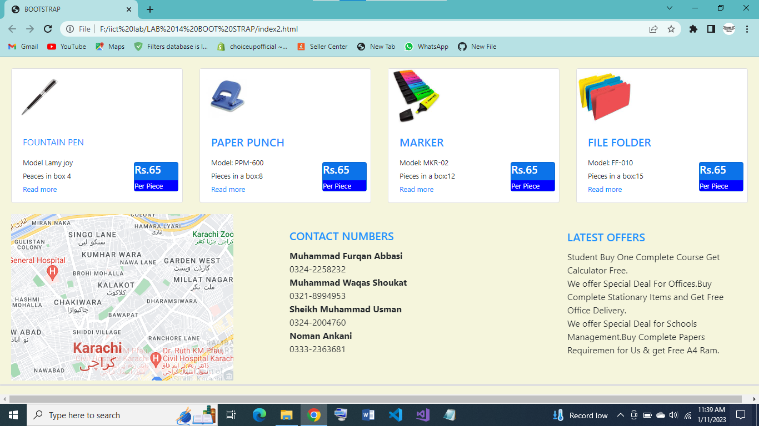

</html>